**Examination of an externally loaded leaking flange joint for leaking using finite element analysis**

**Sam Gilbert, Brian Hoover, Chidhambara Kalusulinga, Michael Regan,** and **Bijoy Verghese**

Department of Mechanical Engineering, University of Illinois at Urbana Champaign

**ABSTRACT**

Bolted flange joints heavily utilize gaskets to create a seal in pipelines. Not only do gaskets experience high operating pressures and external loads, but also elemental exposure affects the integrity of the gasket seal. When seal performance fails, alternative flange joints must be examined. This investigation explores the feasibility of replacing an existing spiral wound gasket on a flange joint with a ring type joint for high pressure pipelines evaluated with Abaqus and with author-created MATLAB FEM solver.

**Keywords**: flange joint, finite element analysis

**1.0 Introduction**

A leak in a flange joint was discovered in an offshore high-pressure gas pipeline feeding an onshore facility. Investigation of the joint identified minor gas leakages in the joint’s spiral wound gasket (Figure 1.1), a component not recommended to be utilized under high pressures and high external loads. An additional root cause of the gas leakage was identified as soil settlement across the pipeline, resulting in a high differential external load on the flange joint. Although leakage risks were mitigated via reduction in gas operating pressure and the installation of a temporary clamp on the joint, a long-term solution was needed.

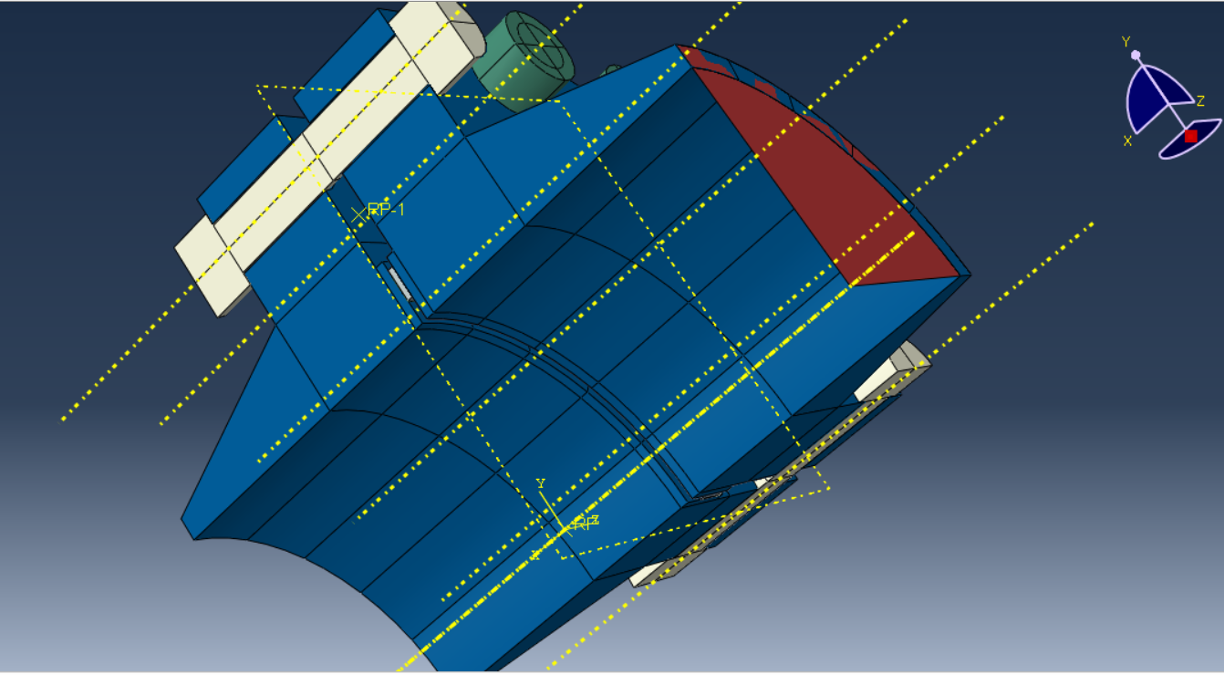

Figure 1.1: Model representation of existing joint and its spiral wound gasket

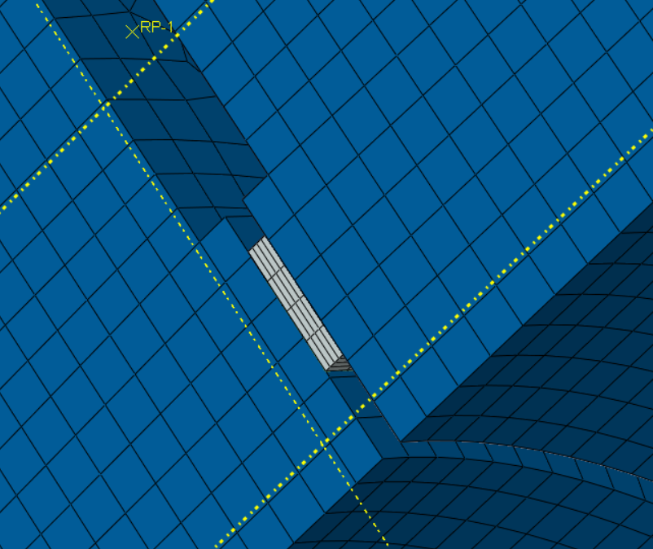

Figure 1.2: Close-up of model representation of existing spiral wound gasket

This investigation explores the feasibility of replacing the existing flange joint and its existing spiral wound gasket (Figure 1.2) with a ring type joint (Figure 1.3).

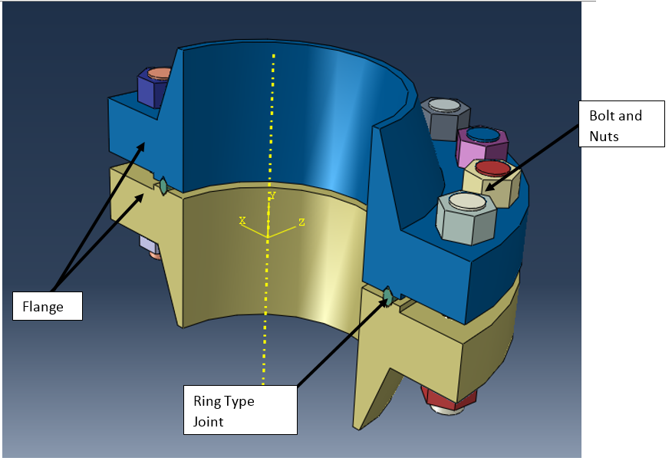

Figure 1.3: Proposed ring type flange joint

The pipeline runs over a hundred kilometers in length and is 12” in diameter. The minor gas leakage was observed at an operating pressure of 60 bar. Further reduction of the operating pressure to 40 bar initially indicated no further leakage, however during verification, gas leakage was still observed at 29.6 bar operating pressure.

**2.0 Geometry**

Two types of geometries were used for analysis, i) Raised face flange ii) Ring groove type flange. The geometry of the 12” 900# flange dimensions was based on reference [1]. CGI style spiral wounded gasket dimensions and oval type ring gasket R-57 dimensions are taken from reference [2]. The basic minor diameter of the 1-3/8” bolt diameter was used for analysis. Also, 1-3/8” nut minimum across flat dimension used to simplify the shape from hexagonal to circular. The component geometries shown in Figure 1 and 2 were simplified in Abaqus to help in the preparation of a well-structured mesh. This typically involved removal of cosmetic and non‐structurally significant features such as small chamfers and fillet radii in noncritical regions. As this is axis symmetric model and to reduce the analysis complexity and computational time, 1/20th of geometry and loading was utilized. Commercial software Abaqus (teaching version) has been used as a finite element solver.

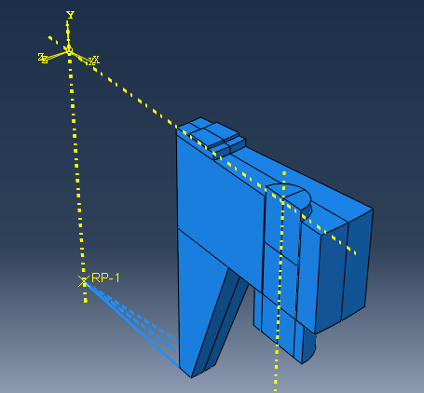

Figure 2.1: Raised face flange model

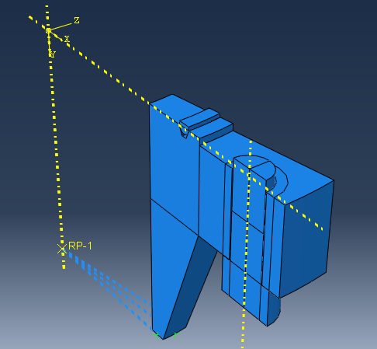

Figure 2.2: Ring type joint flange model

**3.0 Material properties and data**

|  |  |  |  |  |
| --- | --- | --- | --- | --- |
| Part | Material | Young’s modulus | Poisson’s ratio | Co-efficient of thermal expansion |
| Flange |  | 203395 | 0.3 | 1.265e-5 |
| Ring gasket | SS 316 | 200000 | 0.26 | 1.8e-5 |
| Spiral gasket | Graphite filled SS 316 | 18000 | 0.3 | 1.8e-5 |
| Fastener | ASTM A193 Gr.B7 | 204000 | 0.3 | 1.265e-5 |

***Gasket non-linear material properties***

Pressure versus closure behavior can be directly applied to apply to characterize the gasket material in Abaqus. Mechanical characteristics of the gasket material are carried out by a load compressive mechanical test as presented in reference [3] has been used in this analysis. Abaqus software has a provision to input the load compressive mechanical test data. Figure 3 and Figure 4 shows the material properties for spiral wound gaskets and ring gaskets. The non-linear compression behavior with two different unloading curves is considered in the present analysis. If unloading occurs at an intermediate point, the unloading curve is interpolated from neighboring curves. Reloading is assumed to take the same path as the unloading curve for repeated load cycles.

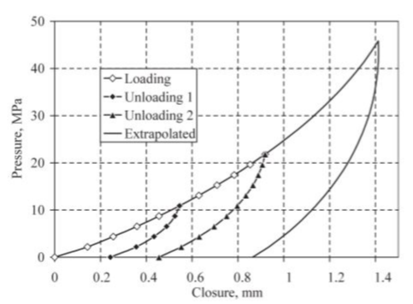

Figure 3.1: Spiral gasket



Figure 3.2: Spiral gasket

**4.0 Discretization and meshing**

Raised face flange was meshed with first order 4-noded tetrahedral elements (Type C3D4). The fasteners and gaskets at the flange interface were modelled 8-noded hexahedral elements (Type C3D8).

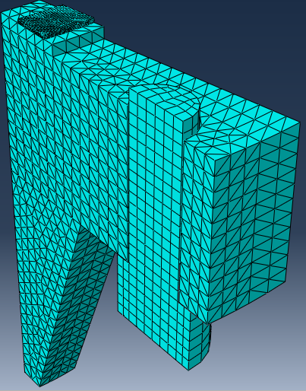

Figure 4.1: Mesh

Contact elements:

Contact elements are generated between the faces of the nuts mating with the flanges. Likewise, contact elements are generated between the gasket faces and the corresponding faces on the flanges.

**5.0 Boundary conditions**

Symmetry sectional faces of the flange, bolt and gaskets are constrained in the Uz translation.

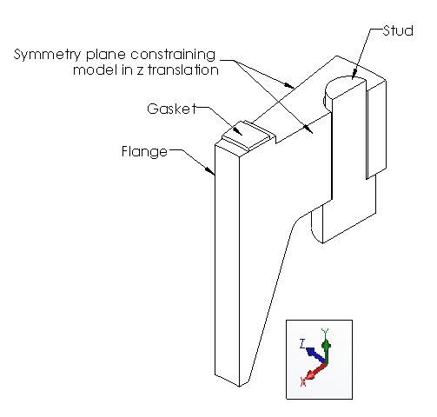

Figure 5.1: Symmetry constraint

Top face of the gasket and stud are constrained in the Uy translation.

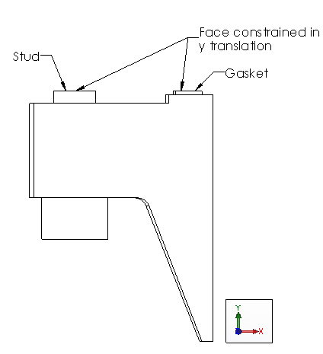

Figure 5.2: Y-axis constraint

**6.0 Loading conditions**

The model was subjected to five individual unit loads; bolt makeup load, internal bore pressure with the associated pressure end load, tension of axial pipe stress, and bending moment that resulted in stress at the extreme fiber of the pipe.

***6.1 Bolt load***

Applied bolt load: 115,598 N. Need to show how we derived this value and the 310.3 MPa value used in the 2D analysis (show general equations and list out the values used) Maybe move to 2D section?

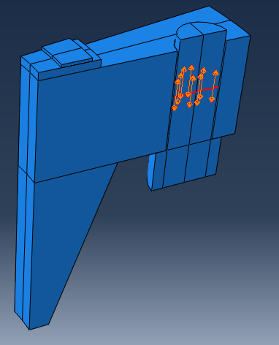

Figure 6.1: Bolt load

***6.2 Pressure***

The applied bore pressure was 10 MPa. The pressure was applied along the bore and to the face of the flange up to the seal diameter. The corresponding pressure end load of 199.619 MPa pressure was applied at the hub end of the flange.

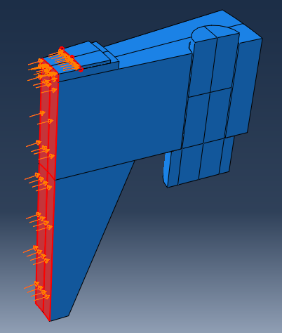

Figure 6.2: Internal Pressure

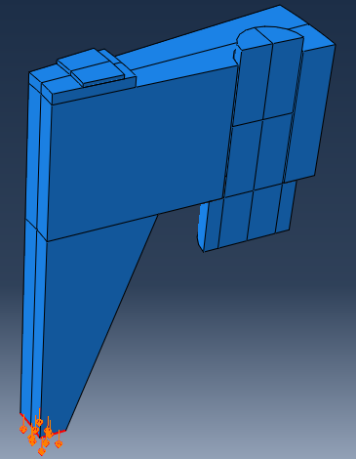

Figure 6.3: Pressure end load

***6.3 Axial force***

Axial force = 12,560 N

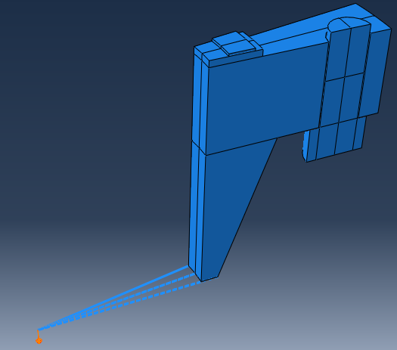

Figure 6.4: Axial force

***6.4 Bending moment***

Moment applied = 75, 480 Nm

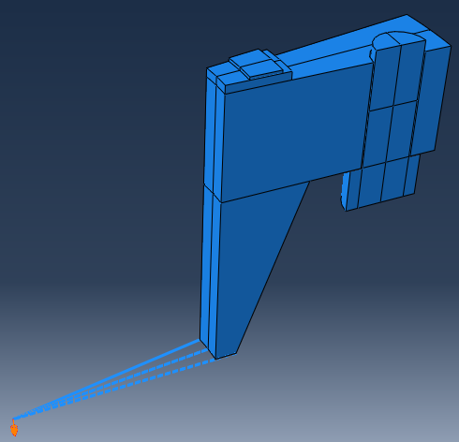

Figure 6.5: Moment

***6.3 Temperature***

Max/min temperature 60/0 degrees Celsius

**CK**

**7.0 Assumptions and limits**

All materials were assumed to be isotropic. Also, the materials were assumed to be without defect, having not experienced any previous loading and unloading cycles. Finally, all material properties were considered to be temperature invariant.

**8.0 Finite element analysis**

This investigation performed two forms of analyses. The team utilized Abaqus finite element analysis software as a solver for both two and three-dimensional investigation. The team also coded their own solver using Matlab. For both solvers, the team modeled a two-dimensional slice of one side of the proposed gasket of the ring type joint (RTF) and modeled the contact force as an equivalent pressure.

***8.1 3-D Abaqus solver***

For the three-dimensional (3-D) models, the stress and deformation states of the two models were considered three-fold: loading stress at bolt-up, relaxation at pressurization, and bending moment application with a temperature increase. Figures 8.1.1-8.1.6 show the initial stress and displacement analyses of the current, spiral wound gasket at these states in both an overhead and profile view. The maximum Von Mises stress on the gasket occurred after bolt-up and was located on the outside edge of the gasket with a calculated value of 403.2 MPa. Also, the gasket was deformed by 0.036mm at this location. The maximum deformation occurred on the inside edge, with a calculated value of 0.071mm. After relaxation due to pressure, the stress in this area remained as the local maximum, but the calculated value due to pressurization decreased to 224.5 MPa while the deformation at this location remained unchanged. The maximum deformation decreased to 0.066mm, again occurring along the inside edge. Finally, after applying the bending moment and experiencing the temperature increase, the stress in this area decreased further to 185.1 MPa while the local deformation increased to 0.039mm. The maximum deformation also increased, to a value of 0.067mm along the inside edge.

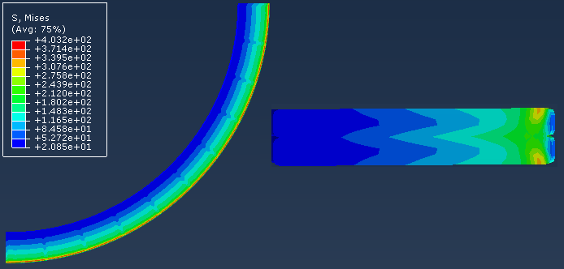

Figure 8.1.1: Spiral Wound Gasket Stress after Bolt-Up

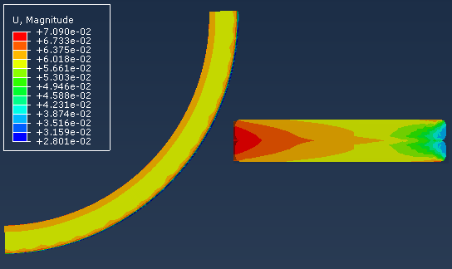

Figure 8.1.2: Spiral Wound Gasket Deform. after Bolt-Up

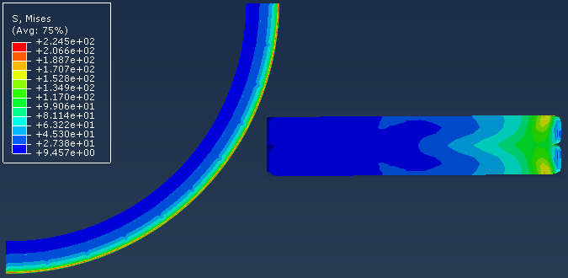

Figure. 8.1.3: Spiral Wound Gasket Stress w/ Pressure

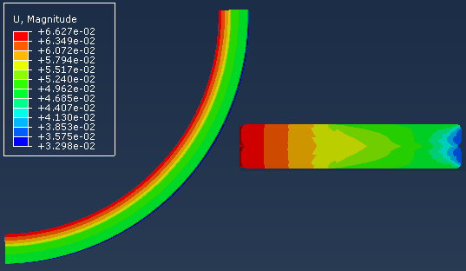

Figure 8.1.4: Spiral Wound Gasket Deform. w/ Pressure

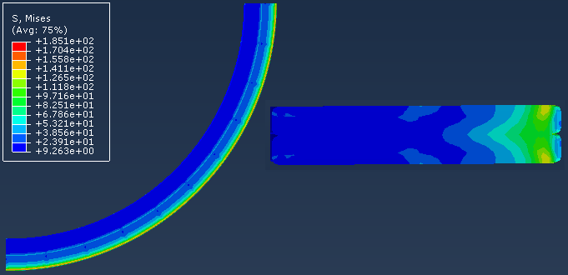

Figure 8.1.5: Spiral Wound Gasket Stress w/ Moment

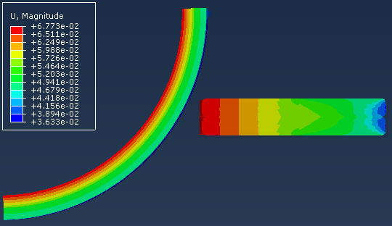

Figure 8.1.6: Spiral Wound Gasket Deform. w/ Moment

A similar model was developed using a ring-type joint (RTJ) and the stress and displacement analyses at the three states are shown in Figures 8.1.7-8.1.12. For the RTJ, the maximum Von Mises stress occurred on the inside of the gasket where it contacts the flange with a calculated value of 480.0 MPa. The gasket deformed by 0.61mm at this location during this step in the process. The maximum deformation occurred on the outside of the gasket, where it contacts the flange, and was calculated at 0.73mm. Once pressurized, the maximum stress decreased to 374.8 MPa while the local deformation increased to 0.67mm and the maximum deformation decreased to 0.72mm. Finally, the applied moment and change in temperature increased the local stress to 400.7 MPa as the local and max deformation remained unchanged.

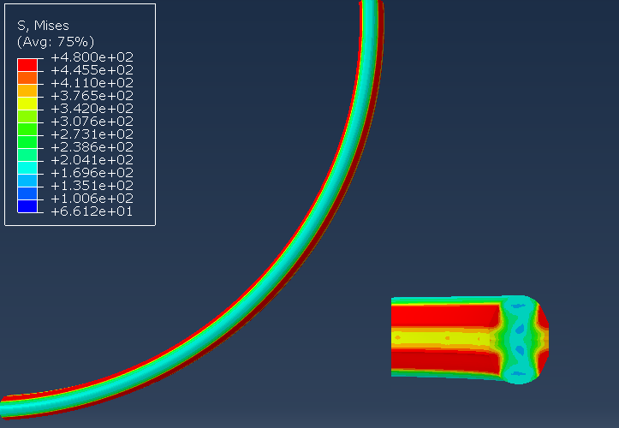

Figure 8.1.7: RTJ Gasket Stress after Bolt-Up

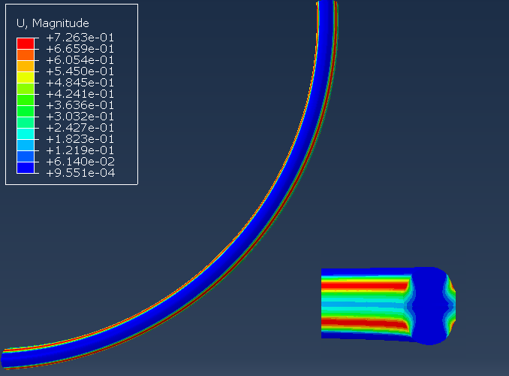

Figure 8.1.8: RTJ Gasket Deformation after Bolt-Up

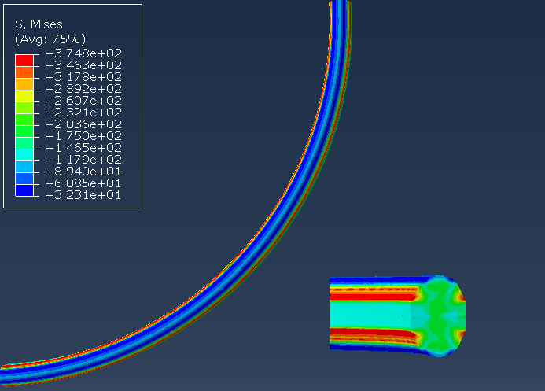

Figure 8.1.9: RTJ Gasket Stress w/ Pressure

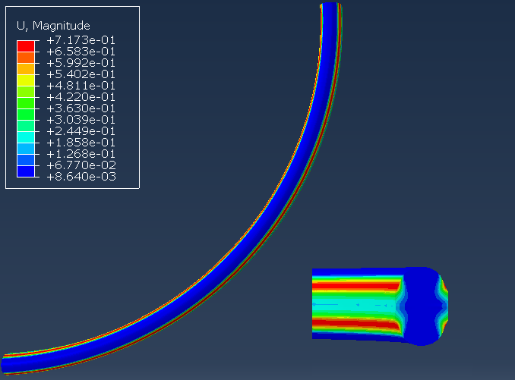

Figure 8.1.10: RTJ Gasket Deformation w/ Pressure

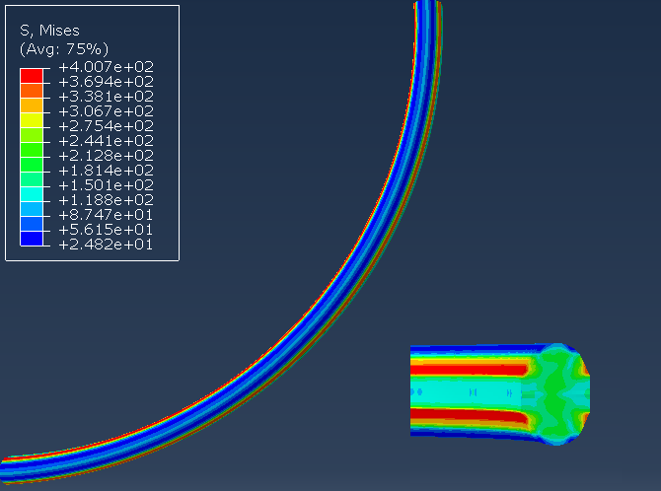

Figure 8.1.11: RTJ Gasket Stress w/ Moment

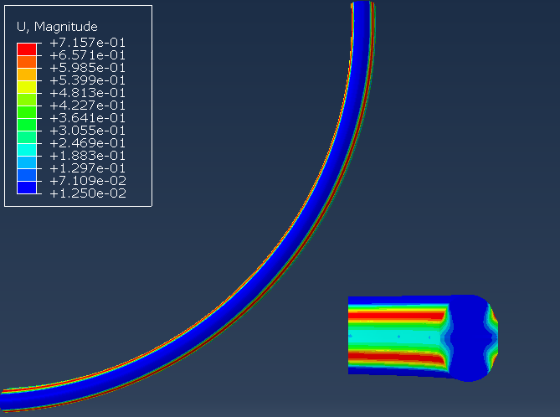

Figure 8.1.12: RTJ Gasket Deformation w/ Moment

***8.2 2-D Abaqus solver***

A two-dimensional (2-D) model was created of the proposed ring-type flange (RTF) joint on Abaqus finite element analysis software. The flange was considered to be symmetric to create a 2-D slice of the cross section of the flange joint and designed with 4-node bilinear plane stress quadrilateral elements (CPS4) as shown in Figure 8.2.1.



Figure 8.2.1: 2-D Abaqus FEA model of proposed flange joint

Two loads from the bolts on the flange were modeled as mechanical forces, and the gas within the pipeline was modeled as a uniform pressure on the inside surface of the proposed flange joint as shown in Figure 8.2.2. The contact forces of the gasket were modeled as an equivalent pressure on the surface of the RTF.



Figure 8.2.2: Loading conditions of 2-D Abaqus FEA model of proposed flange joint

Under such loads as previously mentioned in the loading conditions, the maximum displacement of the flange occurred at the piece’s outer edges where the bolts were loaded as shown on the plotted contours in Figure 8.2.3 with a maximum displacement of 0.3614mm.



Figure 8.2.3: Displacement results of 2-D Abaqus FEA model of proposed flange joint

As shown on the plotted contour in Figure 8.2.4, the maximum magnitude of von Mises stress occurred at the fillet of the proposed ring flange joint with a maximum magnitude of 406.2 MPa.



Figure 8.2.3: Displacement results of 2-D Abaqus FEA model of proposed flange joint

Utilizing the CPS4 element resulted in smooth stress and displacement field contours across the 2-D Abaqus FEA model. With the maximum displacement at the outer edge of the flange where the bolt loads occur, the proposed ring gasket experienced a compressive load at the outer edges of the spiral wound gasket for a tight seal in the pipeline.

***8.3 2-D MATLAB solver***

For the team to program a finite element solver, several simplifications had to be done to the original goal of modeling a gasket between a flange. Ultimately, it was decided to model a two-dimensional cross section of a flange, gasket and bolt, and only model the pressure of the bolt. In addition to being able to more directly leverage techniques taught in the course, the created solver provided an interesting comparison to the more thorough and complex model of Abaqus.

From a software architecture point of view, a finite element solver program was tailored for this specific simplified flange problem in MATLAB. Although much of the code written was specific to this problem, there was a goal to make the code applicable to as many FEM problems as possible. An object-oriented approach was chosen in an attempt to keep as much of the program as general. Often a more primitive MATLAB construct would be wrapped, such as the GlobalStiffnessMatrix type wrapping a sparse matrix. These helper types would also include functions to handle common operations, such as an AddLocalStiffnessMatrix function on the GlobalStiffnessMatrix. Different element types were developed, however only the base Element type and the Triangular3Node2D-Element classes were ultimately used for this investigation.

For simplicity, isoparametric 3-node triangles were chosen for the problem. Analytical expressions were derived for the general elements stiffness matrix and load vector (however due to simplifications and constraints on the problem the distributed load vector was not used for the final results). The derivation began by defining the shape functions:

$$N_{1}= ξ$$

$$N_{2}=η$$

$$N_{3}=1-ξ-η$$

Which leads to the conversion functions:

$$x\left(ξ,η\right)=x_{1}ξ+x_{2}η+x_{3}\left(1-ξ-η\right)$$

$$y\left(ξ,η\right)=y_{1}ξ+y_{2}η+y_{3}\left(1-ξ-η\right)$$

In order to eventually evaluate our B matrix, we evaluate the Jacobian:

$$J=\left[\begin{matrix}x_{1}-x_{3} & y_{1}-y_{3} \\ x_{2}-x_{3} & y_{2}-y_{3}\end{matrix}\right]$$

Where we notice that it is not dependent on the isoparametric variables.

$$J^{-1}=\frac{1}{det\left(J\right)}\left[\begin{matrix}y_{2}-y_{3} & x_{3}-x_{2} \\ y_{3}-y_{2} & x_{1}-x_{3}\end{matrix}\right]$$

Each column of the B matrix is that matrix multiplied by:

$$\left\{\begin{matrix}\frac{∂N_{i}}{∂ξ } \\ \frac{∂N_{i}}{∂η}\end{matrix}\right\}$$

Which when assembled gives us the B matrix:

$$\frac{1}{det\left(J\right)} \left[\begin{matrix}y_{2}-y_{3} & 0 & y_{3}-y_{1} & 0 & y_{1}-y_{2} & 0 \\ 0 & x_{3}-x_{2} & 0 & x_{1}-x_{3} & 0 & x_{2}-x_{1} \\ x_{3}-x_{2} & y_{2}-y_{3} & x_{1}-x_{3} & y_{2}-y_{1} & x_{2}-x_{1} & y_{1}-y_{2}\end{matrix}\right]$$

Again, the matrix does not depend on the local variables. To finish the local stiffness matrix, the matrix actually involving the material properties was found in the literature[4] to be:

$$Λ = \frac{E}{1-υ^{2}}\begin{matrix}1 & υ & 0 \\ υ & 1 & 0 \\ 0 & 0 & \frac{1-υ}{2}\end{matrix}$$

As none of the matrices and vectors depend on the local variables, they can all be pulled out of the integral of the equation for the element stiffness matrix. The integral in the equation evaluates to one half. This is the matrix that was evaluated for every element:

$${\left[k\right]}^{e}={\frac{1}{2}\left[B\right]}^{T}\left[Λ\right]\left[B\right]det\left(J\right)$$

For a distributed load Q, we need to evaluate the integral of the vector of shape functions.

$$\int_{0}^{1}{\int_{0}^{1-η}{\left\{N\right\} dξ dη}=\begin{matrix}\frac{1}{6} \\ \frac{1}{6} \\ \frac{1}{6}\end{matrix} }$$

Leading to the evaluation of the local force vector of:

$$\{r\}^e = Q det(J) \begin{matrix}\frac{1}{6} \\ \frac{1}{6} \\ \frac{1}{6}\end{matrix}$$

Finally, concentrated forces would just be applied to the appropriate elements of the global load vector.

The two-dimensional cross section of the flange, gasket and bolt were originally exported from Abaqus, and from that program, a mesh was created in GMSH. There were several issues with this process. First, the size of the element out of GMSH was 1/100th of what it was in Abaqus. This was corrected in the MATLAB code where, when the mesh was read in, all of the node coordinates were multiplied by 100. Also, the export process did not account any curves and fillets on the model.

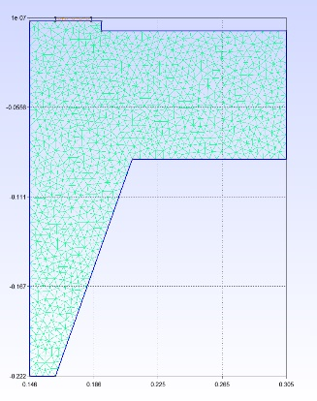

Figure 8.3.1: Mesh for Finite Element Program used in MATLAB

One final issue was that GMSH did not enforce compatibility between the gasket and the flange; there were two completely different sets of nodes for the bottom edge of the gasket and the top of the flange. As such, with the tools at our disposal it was not possible to perform analysis on the gasket with the MATLAB FEM solver. Only the flange under the load of the bolt was modeled.

For simplicity, 3 node triangular elements were used for the mesh, with a maximum unitless value of 0.005. Combined with the material properties used in Abaqus, the local stiffness matrices were derived. Due to the small size that the bolt pressures were applied to, the pressures were converted to a concentrated force at the node closest to the center of the area the bolt.

With the magnitudes of the forces evaluated, they were applied to the node closest to the center of each area the pressure was being applied. The global stiffness matrix wrapped an instance of a sparse matrix that is built into MATLAB, and the global load vector was assembled. For this problem, the pressure was modeled as a boundary condition on the left side of the flange preventing the flange from moving in the X direction. To account for symmetry, the top of the gasket was fixed in the y-direction. The boundary conditions were hard-coded into the program, eliminating rows and columns for node elements that were fixed or where the axis of symmetry cut the cross section. The displacements of the remaining nodes were found by inverting the remainder of the global stiffness matrix and multiplying it with the load vector that remained after eliminating rows due to boundary conditions. The reaction stresses and strains where then computed, and plots of the stress and displacements were generated.

***8.4 Comparison between MATLAB code and Abaqus results***

Under the bolt load of 199.544 MPa, the displacement had a maximum of 0.2203 mm. The results for the maximum loading were reasonably close to the Abaqus results, being only 5.3% less than the maximum displacement evaluated in Abaqus.

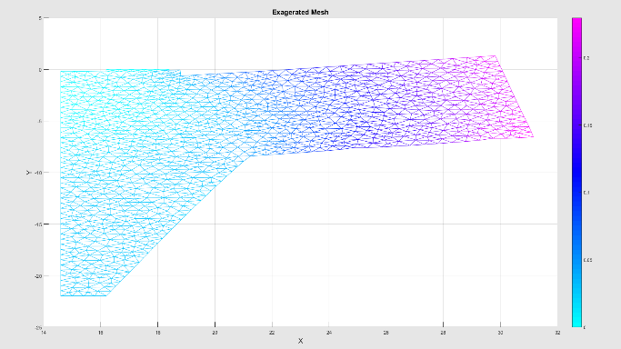

Figure 8.4.1: Mesh under load, displacements exaggerated by a factor of 100

The stress forces on the flange had a similar distribution as the Abaqus model, mainly showing large stress at the lower convex corner and at the boundary condition where the gasket would be. However, the peak value was significantly lower, 45 MPa, than what Abaqus evaluated, being nearly an order of magnitude off from Abaqus’s value of 261.2 MPa. It is strongly suspected that there is an error in the written FEM program causing this discrepancy.

**9.0 Discussion**

***9.1 Discussion and analysis of results***

Would the flange leak? No

Min stress of gasket is 69 MPa

**Bijoy**

***9.2 Implications for design***

Direct application for proposal to replace existing flange joint and spiral wound gasket

**Bijoy**

**10.0 References**

[1] ASME B16.5: Pipe Flanges and Flanged Fittings (2017 Edition)

[2] ASME B16.20: Metallic Gaskets for Pipe Flanges (2017 Edition)

[3] A study on the sealing performance of ﬂange joints with gaskets under external bending using ﬁnite-element analysis by G Mathan and N Siva Prasad

[4] 2D Triangular Elements - http://www.unm.edu/~bgreen/ME360/2D%20Triangular%20Elements.pdf

Accessed on 2018 Dec 06